**Date Submitted: 12/3/18**

**Task 02: Download and Debug with CCS**

3.3V

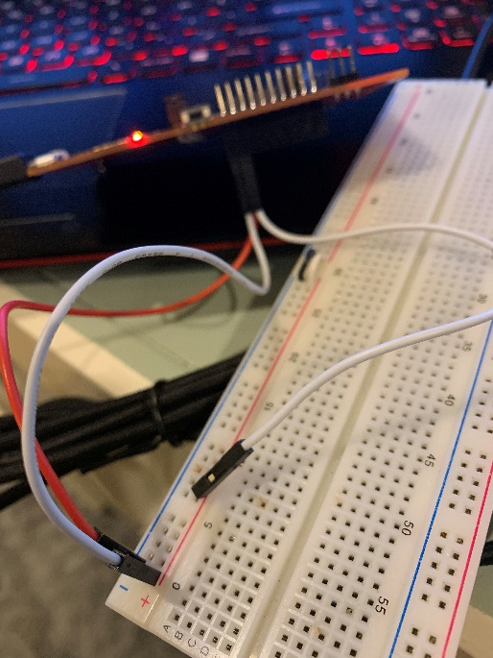D:\Oji\Documents\School\Fall2018\CPE 403\CC1350_Labs\Lab 4\Task23v3.PNG

GND

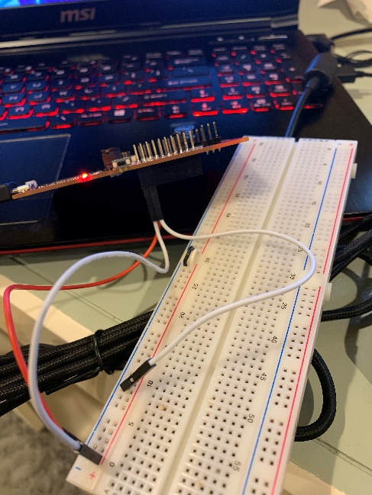



**------------------------------------------------------------------------------------**

**Task 03: Download and Debug with SCS**



